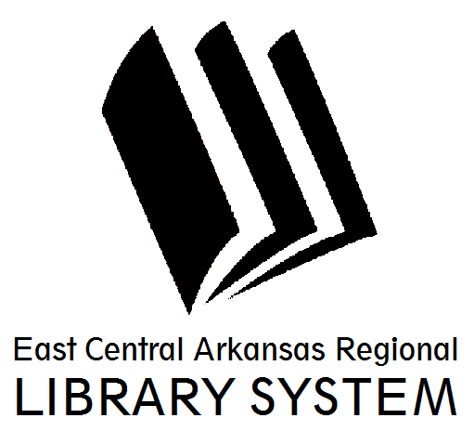
East Central Arkansas Regional Library System
410 E. Merriman Avenue, Wynne AR 72396
PRESS RELEASE

Date: 05/24/2016
For more information, contact Asti Ogletree, Youth Services Coordinator at 870-238-3850
_____________________________________________________________________________________
On Your Mark, Get Set, READ! It’s time for the annual Summer Reading Program at the Cross County Public Library. Readers of all ages are encouraged to register and participate in a summer full of fun at our local library. The library will host weekly programs for preschoolers, families, school age, and adults from June 1st until July 27th.
Preschool Storytime with Mrs. Tree will be every Wednesday at 10am. Each week Mrs. Tree will have a different theme to engage children and a craft for them to make and take home. Every Thursday at 3:30pm beginning June 2nd, Mrs. Tree will also offer a school age Storytime entitled A.T.L.A.S. Children between the ages of 6-10 are encouraged to come out and make a project and discuss a novel with Mrs. Tree.
June 1st come and enjoy Lego’s and board game favorites from 3:00-4:30pm.
June 8th Team up and maneuver through the library obstacle course. Children will be put on teams and timed to see which team will be the obstacle course champions.
June 15th want to honor that special Father figure in your life? Come and Hear a Father’s day inspired story. Each child will get to make and take home a father’s day craft.
June 22nd prepare to be amazed, at the Tommy Terrific Magic Show.
June 29th Storyteller Will Stuck will come and perform his HOOPLA! show, a lively variety of stories, songs and general nonsense.
July 6th Get up and Move at the library. Children will “Get up and Move” with Blake (Coach) Lambert, Wynne Public School teacher.
July 13th Learn about “Planet Health” with Bob Tarter (“The Animal Guy”). Space is limited so please arrive early.
July 20th is Campfire Stories and S’mores with the Elliott Clan. Chris Elliott, Local Boy Scout Leader, and family will lead participants in fun stories to tell by the campfire. S’mores will be provided at the end of Storytime.
July 27th is the SRP Finale Line Dance Party!!! Come out and dance with your local library staff.
The Cross County Library will also offer teen and adult programs which are listed on our website.
For more information about story times and programs please visit us at www.ecarls.org or at facebook.com/crosscountylibrary. You may contact us at (870) 238- 3850. Our friendly staff is always looking forward to assisting you.

Asti Ogletree
Youth Services Coordinator
Cross County Library
aogletree@crosscountylibrary.org
(870) 238-3850

