East Central Arkansas Regional Library  410 Merriman Ave E  Phone Number  Email address  website  News Release | 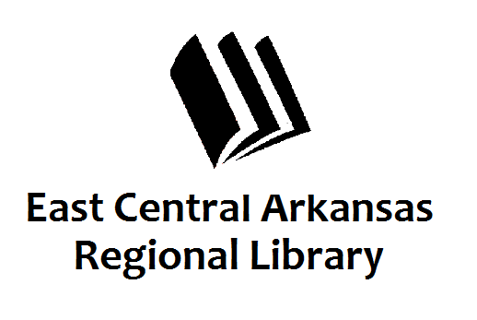

Media Contact:

Claire Miller

870-587-0580

cmiller@crosscountylibrary.org

April is National Car Care Month: East Central Arkansas Regional Library Celebrates with Automotive Repair Help Available Online

ChiltonLibrary provides authoritative, money-saving car care guidance

City, State, Month, Day, 2016 – Studies show consumers are keeping their cars longer. With more older cars on the road, repairs are on the rise. People in Cross and Woodruff Counties interested in taking wrench in hand to save money now have a resource to help.

Residents in Cross and Woodruff Counties can access reliable automotive help online 24/7 through ChiltonLibrary, a resource available on the East Central Arkansas Regional Library website. Trusted by automotive enthusiasts for more than 100 years, ChiltonLibrary supports “do-it-yourselfers” of all skill levels. No other source contains more years, makes, and models.

“During National Car Care Month, we’re highlighting ChiltonLibrary, an online resource that helps patrons save money on car repairs by offering expert, step-by-step guidance on how to conduct repairs themselves, or by having greater knowledge about their vehicle when taking it to a professional for service,” said Claire Miller, Deputy Director of East Central Arkansas Regional Library “Residents with a library card can tap into this resource through their home computers, iPads or tablets around the clock, in addition to being able to access the information here at the library.”

ChiltonLibrary, from Gale, part of Cengage Learning, provides access to repair, maintenance and service information on the most popular cars, trucks, vans and SUVs on the road today as well as many new vehicles! This continually updated resource provides step-by-step repair procedures as well as troubleshooting guides and diagnostic trouble codes, Photos, illustrations, diagrams, and multimedia (videos and animations) simplify even the most complicated tasks.

In addition to finding repair information, library users are able to:
- Look up recalls and service bulletins
- Find estimated labor time helping users confidently estimate repair costs
- Prepare for ASE mechanic certification with test prep quizzes

ChiltonLibrary supplies a solution for the “do-it-yourselfer” that is easy to use no matter the skill level. With product enhancements such as mobile optimization and ReadSpeaker text-to-speech technology, ChiltonLibrary is a perfect solution for all vehicle needs. Repair, maintenance and specification tables provide critical data on thousands of domestic and imported models of cars and light trucks from 1940 onward.
Cross and Woodruff County residents can access ChiltonLibrary from library computers or remotely by visiting the library’s website www.ecarls.org.

For questions or more information, please contact Claire Miller at 870-587-0580.

About Gale
Gale, a part of Cengage Learning, believes the library is the heart of its community, driving meaningful and measurable outcomes for individual users and groups. Gale is a partner to libraries and businesses looking to deliver educational content, tools and services to support entrepreneurship, encourage self-directed learning, aid in research and instruction, and provide enlightening experiences. Gale has been a leading provider of research and education resources to libraries for 60 years and is committed to supporting the continued innovation and evolution of libraries and their users. For more information, visit www.gale.cengage.com.

###

