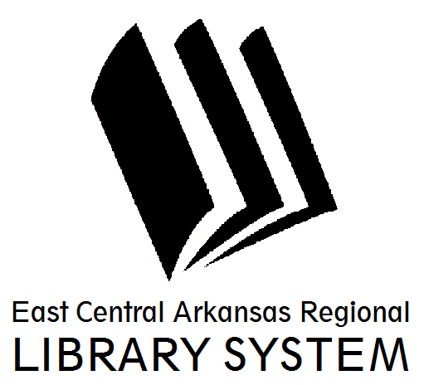
East Central Arkansas Regional Library System
410 E. Merriman Avenue, Wynne AR 72396
PRESS RELEASE

Date: 9/1/2016
For more information, contact Claire Miller, Deputy Director 870-587-0580
_____________________________________________________________________________________
TumbleBooks @ Your Library
Our Library has a subscription to TumbleBookLibrary, and your family can access it from home! It’s unlimited, and it’s FREE for you to use from home! TumbleBookLibrary is an online collection of e-books for children. They are a great way to encourage tech-savvy kids to enjoy reading! There are over 250 animated, talking picture books! The site also features Spanish and French books, read-along chapter books, non-fiction books, and exciting games and puzzles! We hope that you will get the chance to check out the collections with your child! To login, use the following – username: ecarl; password: libra. You can use your computer, tablet, or mobile phone! All you need is an internet connection. There are no downloads: books are streamed right to your device at the click of a button.
Does your family enjoy graphic novels? With TumbleBookCloud you will have unlimited access to a fantastic collection. Our selection of Graphic Novels is perfect for readers both young and young at heart. Next you'll want to check out our Enhanced Novels. This collection of classic literature, YA novels, middle school chapter books, and foundational non-fiction texts features professional narration paired with line by line highlighting. Follow along with the narrator until you are ready to read on your own! In our Enhanced novels and our eBooks you can make notes as you read, or create bookmarks so you'll never lose your place! Adjust the size of the text, or the background colour for a fun customizable reading experience. And don't forget to check out the hundreds of Audiobooks, National Geographic videos, and common core aligned educator resources available around the clock! All of our titles and resources are available anywhere you have an internet connection: scroll through a Graphic Novel on your iPad, read a classic novel on your computer, or listen to an audiobook on your smartphone!

Happy Tumbling, everyone!
For more information on library resources, programming, and more, please visit us online at www.ecarls.org. Don’t forget to like your branch on facebook to keep up with the latest news.

Claire Miller
Deputy Director
Cross County Library
cmiller@crosscountylibrary.org

