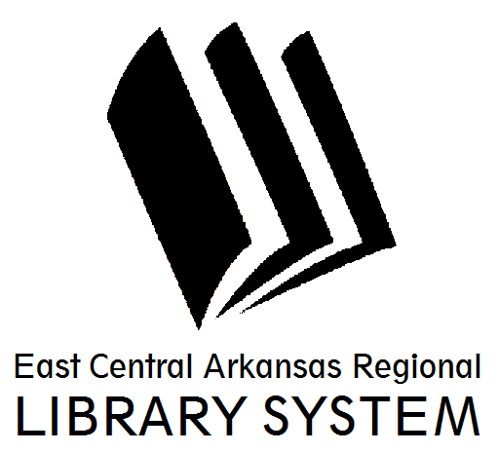
East Central Arkansas Regional Library System
410 E. Merriman Avenue, Wynne AR 72396
PRESS RELEASE

Date: 01/09/2017
For more information, contact Asti Ogletree, Youth Services Coordinator at 870-238-3850
_____________________________________________________________________________________
The Cross County Library will host “Kinky, Curly, Conversations (and product swap)” at 6:00pm, January 31, 2017, at the Wynne location. This program series is an open forum and product swap for women and men with natural or curly hair. The speaker for January is natural hair stylist, Samantha Horton, of Marian, Arkansas. She will be in attendance to educate, answer questions, and even provide styling suggestions. Light refreshments will be provided.
This program aims to connect those in Cross County with natural hair or those that are transitioning to natural hair. We encourage participants to bring products they like or those that they don’t and swap them with someone that may want to give them a try.
The Kinky, Curly, Conversation will be every 5th Tuesday, dates are as follows:

January 31, 2017 May 30, 2017 August 29, 2017 October 31, 2017

For more information about the program please visit us at www.ecarls.org or at facebook.com/crosscountylibrary. You may also contact us at (870) 238- 3850. Our friendly staff is always looking forward to assisting you.

Asti Ogletree
Youth Services Coordinator
Cross County Library
aogletree@crosscountylibrary.org
(870) 238-3850

