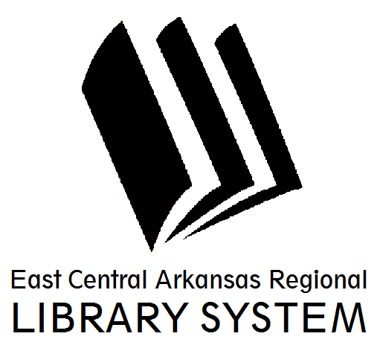
East Central Arkansas Regional Library System
410 E. Merriman Avenue, Wynne AR 72396
PRESS RELEASE

Date: 04/3/2017
For more information, contact Asti Ogletree, Youth Services Coordinator at 870-238-3850
_____________________________________________________________________________________
In observance of National Poetry month The Cross County Public Library will host two poetry programs.

April 24, 2017 through April 28, 2017- Library staff and patrons are encouraged to participate in an activity called, “Poetry Break” based off the book “Poetry Break” by Caroline Feller Bauer. Each day at noon, a member of the library staff will announce “Poetry Break” and then read or recite a poem aloud.

This simple activity is geared to introduce our patrons to poetry and our love for written and spoken word. We are encouraging our patrons to not only witness the readings but to come out and participate as well. Selected poems can be by any author or self-written.

April 25, 2017- Open Mic Poetry with WHS Ink club. This program will feature community poets and winning poetry from the WHS Ink club. Poetry lovers of all ages are encouraged to come out participate and enjoy the spoken word.

For more information about programs please visit us at www.ecarls.org or at facebook.com/crosscountylibrary. You may contact us at (870) 238- 3850. Our friendly staff is always looking forward to assisting you.

Asti Ogletree
Youth Services Coordinator
Cross County Library
aogletree@crosscountylibrary.org
(870) 238-3850

