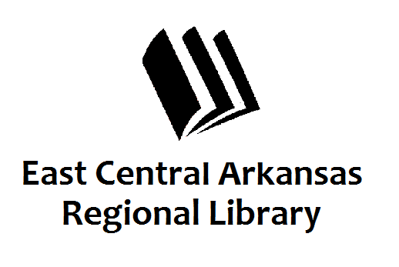
PRESS RELEASE
Date: 3-18-16
For more information, contact:
Claire Miller, Deputy Director at 870-587-0580
_____________________________________________________________________________________
CROSS COUNTY LIBRARY PRESS RELEASE 3-18-16
April Programming at Cross County Library
Cross County Library in Wynne is excited to partner with the Cross County Arts Council and host an exhibit with art from seniors in Wynne and Cross County School Districts. The reception will be held on Tuesday, April 5th from 5pm to 7pm. Seated Yoga will be the 1st and 3rd Wednesday of the month at 1:30pm in Wynne. No mats required, just wear comfortable clothing. April is National Poetry Month so we’ll be hosting poetry breaks at 12pm in Wynne. Stop by and hear our staff read some poetry.
Sensory Story Time is the 1st Thursday of the month at 6pm in Wynne. We watch stories on the screen, dance and sing, play instruments, and make something fun to take home. Come and get all of your senses involved.
The Adult Book Clubs in Wynne will be discussing The Kitchen House on Monday, April 11th at 11am and 6pm. We’ll discuss the same book in Parkin on Tuesday, April 12th at 5:30pm. Also, on Tuesday, April 12th in Wynne, we’ll be hosting Beverly Cleary Teen Night at 6pm. Teens will discuss their favorite Beverly Cleary book to pay homage to this great author.
We’re hosting Microsoft Office Basics class on Monday, April18th at 9am in the Wynne Library Computer lab. Space is limited so please call and get on the list. On Thursday, April 21st from 3:30pm to 4:30pm in Wynne, Miss Tree will be hosting After School Junie B. Jones Read Day in honor of the author’s birthday. Come and listen to excerpts from Miss Tree’s favorite Junie B. books.
The last week in April is Money Smart Week at your local library. On Monday, April 25th @ 6pm, Clay Jenkins from Edward Jones will be here to talk about Investing in Your Future. On Tuesday, April 26th at 6pm, we’ll be hosting a Poetry Slam for Adults and Teens at the Wynne Library. Bring your own poetry or read from your favorite poetry book. The same evening at 5:30pm in Parkin, we’ll be hosting Feed the Pig Family Night. Bring the family to learn about money and saving. We’ll be making piggy banks! On Thursday, April 28th @ 6pm, we’re hosting The Spending Game Family Night as a partnership with the Cross County Extension Office. This is fun an interactive way for the entire family to learn about spending, saving, and money.
If you have any questions, don’t hesitate to call us at 870-238-3850. Press 3 to speak to someone at the front desk. Don’t forget to visit us online at www.ecarls.org and on Facebook. Your local branch has their own Facebook page.

