CROSS COUNTY LIBRARY
BOARD OF TRUSTEES MEETING

January 31, 2017

Call to Order and Roll Call: The meeting was called to order at 4:08pm by Board Chair, Joy Shepherd. Trustees present were George Anne Draper, Jerry Harvey, Renee Boeckmann, and Kitty Bingham.

Library staff present: John Paul Myrick, Executive Director; Claire Miller, Deputy Director; Asti Ogletree; Lori Hunt.

Public Attendance: Judge Donnie Sanders and Mike Hamrick.

Public Participation and Comments: N/A

Reading and Adoption of Minutes: Joy asked for a motion to approve the minutes from December 21, 2016. George Anne moved to accept the minutes. Jerry seconded the motion. All aye, motion carried.

Financial Reports, December 2016: Joy asked for discussion and a motion to approve the financial reports from December. Renee asked what was covered in the Janitorial Line Item and John Paul said that it was supplies as well as payment to Calvin for cleaning 3 times a week. She also asked about the miscellaneous line item and John Paul explained that it was used for projects that didn’t quite fit into the other line items of the budget. For example, the new siding installed last year went into that category. Renee also asked about upkeep of the grounds and John Paul explained that Ray’s Lawn Care took care of the landscaping and we had another business working with the sprinkler system. The contract was for 12 months and open ended so that after that time, the library could choose to work with someone else if they chose. Ray’s Lawn Care came in with the lowest bid when the job was bid out 2 years ago. John Paul said that he would like to have a company that could handle all of the needs, and there may be more businesses out there now that could do that. John Paul also mentioned that the Crepe Myrtle on the side of the building is growing into the eve, and something will have to be done about it. Renee suggested cutting it back. Kitty asked where internet showed up in the billing and John Paul said it was in with telephone. George Anne asked if the library had applied for e-rate and John Paul said that we had receive around $13,000 in discounts through e-rate funding. Kitty then asked about travel conference expenditures on 12/1/2016. John Paul said this was from our trip to Fargo, ND for conference and that the billing would have come through at that time. Renee asked how pays the building insurance for the library and John Paul said it was the County. John Paul also pointed out that some expenditures from December aren’t reflected in these reports but they will be charged to the 2016 budget. Jerry Harvey moved to approve the financial reports for December 2016. George Anne seconded the motion. All aye, motion carried.

Operations and Staff Reports: Claire gave some highlights of her December 2016 reports and then a recap of 2016 as a whole. Some numbers were down but the library is still being heavily used. John Paul noted that if wifi users were included in the internet usage totals, our numbers would be much higher.

John Paul also mentioned a vandalism issue that will likely be in the paper soon. George Anne asked about smoking near the building and if the library property was a non-smoking zone. John Paul said that it wasn’t. Concerns were raised about patrons smoking close to the entrance where children come in. John Paul said that he would poll other libraries to see what their policies and procedures are.

Renee moved to approve the operation reports. Jerry seconded the motion. All aye, motion carried.

Unfinished Business:

CCL 2017 General Fund Budget: John Paul asked the trustees to look at the proposed budget revisions before them. Joy asked if the adjustments had cut from book budgets. Because of an unexpected $15,000 increase in millage and the bonus money, John Paul was able to raise the book and programming budgets back up to where they had started. George Anne said that she was happy to see that the book budgets were back up. John Paul said that he was not able to put all the funds back into the budget but most line items are higher than what we had last year.

John Paul also mentioned that Marketing is the library system’s biggest issue. He plans to reach out to a ASU class to do a marketing study for us to see what we can approve.

Renee moved to approve Budget B, George Anne seconded the motion. All aye, motion carried.

New Business:

Election of Board Officers: John Paul reminded the Trustees that it was time to elect officers. After discussion, it was decided that Joy Shepherd would remain in the position of Board Chair. Kitty Bingham was chosen as Vice Chair because she had been on the board the longest after Joy. As such, George Anne Draper became the Treasurer. Jerry moved to approve Joy as Chair, Kitty as Vice Chair, and George Anne as Treasurer. Renee seconded the motion. All aye, motion carried.

The Trustees also had to choose representatives for the ECARL Board. Joy Shepherd, Chair, was automatically assigned to the ECARL Board. George Anne and Kitty agreed to stay on the ECARL Board. Joy moved to approve these appointments, Renee seconded. All aye, motion carried. Renee was named as representative to the Friends of the Library in Wynne and Jerry was named representative to the Parkin Friends of the Library.

Proposed Resolution 2017-A, Setting Depositories and designating signatories to Library Deposit Accounts: John Paul said that there is a new requirement for Resolution stating everything the Trustees had voted from. Cross County Bank requires such a document to add signatories. After filling in the positions, John Paul asked Joy to sign it. Kitty asked if the library had to do the Resolution last year and John Paul said no, it was a new requirement. She also mentioned that she didn’t feel it was right for John Paul to be listed as Secretary of the Board since he is not a member of the Trustees. John Paul pointed out that it was in the Bylaws. Joy moved to approve the resolution, Jerry seconded. All aye, motion carried. John Paul mentioned that the Trustees could be reimbursed for mileage when traveling out of county for meetings.

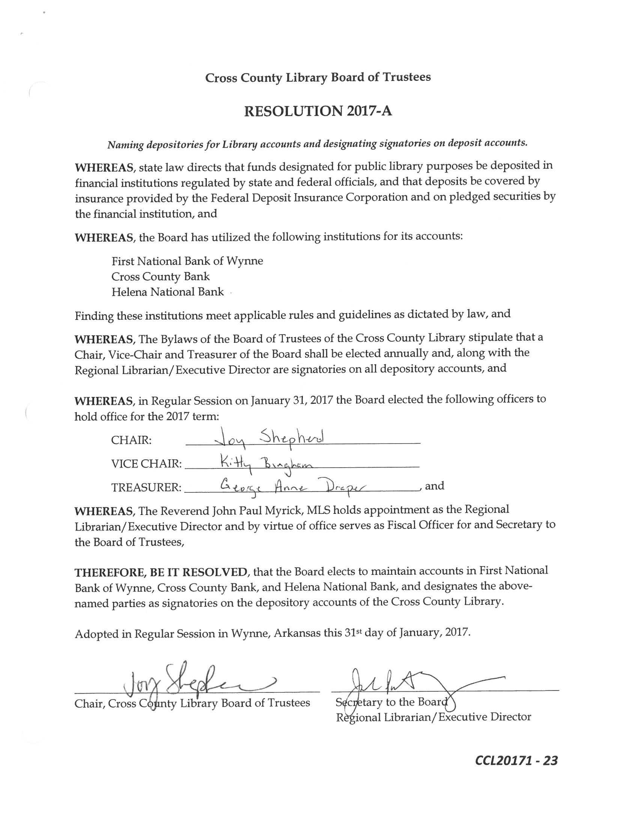

Trustee Comment Period: John Paul said that he would like to welcome Renee Boeckmann to the Board and said thank you to Judge Sanders for his appointment.

Adjournment: Joy asked for a motion to adjourn the meeting. Jerry moved to adjourn the meeting and Renee seconded the motion. All aye, motion carried. Meeting was adjourned at 5:02pm.

Respectfully submitted,

Claire Miller, Deputy Director

