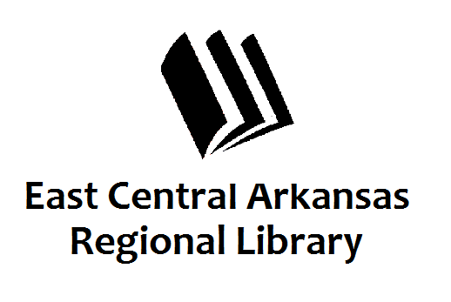
PRESS RELEASE
September 17, 2018
For additional information, contact:
Karen Golden, Operations Manager,
Woodruff County Libraries at 870-347-5331.

Banned Books Week

Movies at the Augusta Library

AUGUSTA, September 17th—
What do To Kill A Mockingbird, The Sun Also Rises, Call Of The Wild, Animal Farm, and Lord Of The Rings all have in common? They have all made the banned books list. The Woodruff County Library in Augusta will be showing these movies based on the books during Banned Books Week, September 24-28.

Monday’s movie will be To Kill A Mockingbird and the time is 4:00 - 6:00 pm. Tuesday through Friday movies will be shown from 2:00 – 4:00 pm. Tuesday’s movie is The Sun Also Rises. Wednesday we will show Call Of The Wild. Thursday will feature Animal Farm. And Friday will be Lord Of The Rings: Fellowship Of The Rings.

All of these programs are free and open to the public. Come enjoy a banned book with us!

The Augusta Library is located at 201 Mulberry Street. For more information, please contact Karen, Melinda, or Naomi at 870-347-5331.

