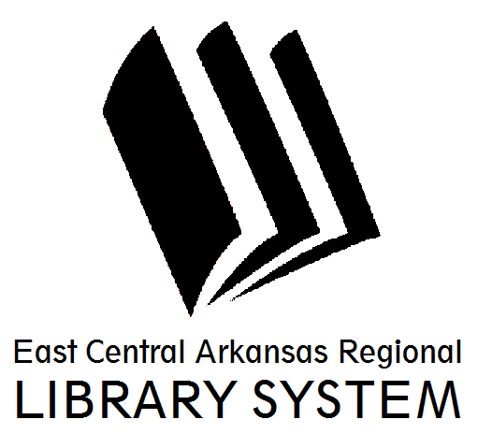
EAST CENTRAL ARKANSAS REGIONAL LIBRARY SYSTEM
Minutes of the Board of Trustees
November 7, 2013
The Board of Trustees of the East Central Arkansas Regional Library System was scheduled to meet on November 7, 2013 at the Cross County Library in Wynne. Board Chair Carolyn Imboden called the meeting to order at approximately 12:10 PM. Board members Kitty Bingham, George Ann Draper, Joy Lynn Bowen, Joy Shepherd and Reta Ragland were present, as was John Paul Myrick, Executive Director and Sherry Reynolds, Library Assistant at the Cross County Library.
The Chair announced that a quorum was not present to conduct business, and adjourned the meeting at 12:11 PM. Members is attendance discussed activities at both libraries, the status of ECARLS property in Woodruff County, holiday hours and meeting schedules, and other items, but no action was officially taken.
Respectfully submitted,

John Paul Myrick, MLS
Executive Director/Regional Librarian

