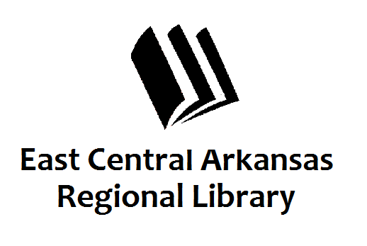
PRESS RELEASE
Date: 5-13-16
For more information, contact:
Claire Miller, Deputy Director at 870-587-0580
_____________________________________________________________________________________
CROSS COUNTY LIBRARY PRESS RELEASE 5-13-16
More Programming at Cross County Library
Cross County Library in Wynne recently received an exhibit all about the history and progression of Frankenstein. We’re very excited about this exhibit so we’ll be hosting several special programs on the topic. On Thursday, May 19th at 6pm in Wynne, we’re hosting a Frankenstein Art Contest. Kids will be drawing their interpretation of the monster. A small prize will be given to the winner. Monday, May 23rd at 6pm in Wynne, we’re hosting a book discussion entitled “Who is the Monster?” Copies of the book will be available. On Tuesday, May 24th @ 5:30pm in Wynne, we’ll be hosting Family Movie Night. You don’t want to be late for this very important date. Wednesday, May 25th at 2pm, Miss Sherry is going to be showing us how to make Memorial Day Wreaths. Supplies are limited but we will have instructions for you to take home. Give us a call if you plan to attend. Adult Coloring is back with a Frankenstein Twist. Come and color the famous monster. Don’t forget, all libraries will be closed on Monday, May 30th in honor of Memorial Day. Tuesday, May 31st in Wynne, we’ll be back with another version of the Monster movie. This version is rated “R”. Minors will have to be accompanied by an adult if they wish to attend. This movie pays homage to Mary Shelley’s vision.
If you have any questions, don’t hesitate to call us at 870-238-3850. Press 3 to speak to someone at the front desk. Don’t forget to visit us online at www.ecarls.org and on Facebook. Your local branch has their own Facebook page.

