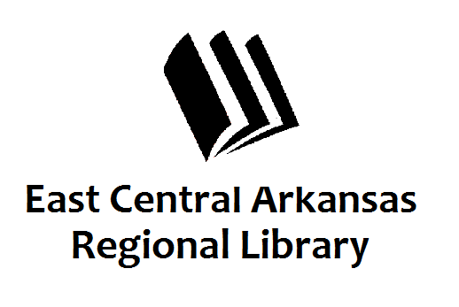
PRESS RELEASE
Date:
For more information, contact:
Claire Miller, Deputy Director at 870-587-0580
_____________________________________________________________________________________
CROSS COUNTY LIBRARY PRESS RELEASE 2-23-16
March Programming at Cross County Library
March is a busy month at Cross County Library Branches. Every 1st and 3rd Tuesday of the month at 6:32pm, our Dungeon Master Shaggy Knighton leads our Dungeons and Dragons Campaign in Wynne. Teen Club will meet in Wynne on Tuesday, March 8th at 6pm.
All ECARL Libraries will be closed on Friday, March 11th for Staff Development.
On Monday, March 14th at 11am and 6pm, The Club will be discussing biographies about women we admire for Women’s History Month. Tuesday, March 15th @ 5:30pm, we’ll host the same discussion at the Parkin Library. Seated Yoga with Bobbie Powell meets every 1st and 3rd Wednesday of the month at 1:30pm in Wynne. This program is designed for senior adults, but all adults are welcome to attend. Adult Coloring will be every 4th Thursday for the month at 6pm in the adult reading area in Wynne. Come for coloring, coffee, and conversation. We’ll also be hosting a Resume Basics class on Monday, March 28th at 9am. If you’re searching for a job, or just want to up your skills, this is the class for you.
We’re excited to host the art show and reception for Student Art Month this year. The reception will be on Thursday, March 10th from 5pm to 7pm. Awards will be presented. Come out and support our students. Sensory Story Time is the first Thursday of the month at 6pm. This month, we’ll be writing our own sensory poems for Poetry Month. Each month, we watch a story from Tumblebooks, sing and dance, and make something to take home. We get all of the senses involved. Preschool Story Time is every Wednesday at 10am in Wynne. Everyone has fun with Miss Tree.
The Friends of the Library meet in Wynne on the 3rd Thursday of the month at 5pm. If you’d like to get involved, we’d love to have you.
If you have any questions, don’t hesitate to call us at 870-238-3850. Press 3 to speak to someone at the front desk. Don’t forget to visit us online at www.ecarls.org and on Facebook. Your local branch will has their own Facebook page.

