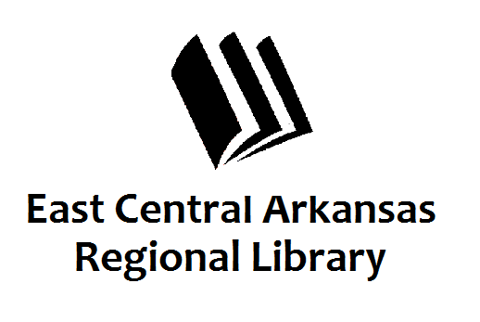
PRESS RELEASE
September 15, 2017
For additional information, contact:
Karen Golden, Operations Manager,
Woodruff County Libraries at 870-347-5331.

Banned Books

Banned Books Week at the Augusta Library

AUGUSTA, September 15th –
What does the Bible, Harry Potter, Huck Finn, and Little Bill have in common? They’ve all been banned! Come by and check out some of the banned books we will have on display at the library during Banned Books Week, September 24th-30th.

The Augusta Library is located at 201 Mulberry Street. For more information, please contact Karen or Melinda at 870-347-5331.

