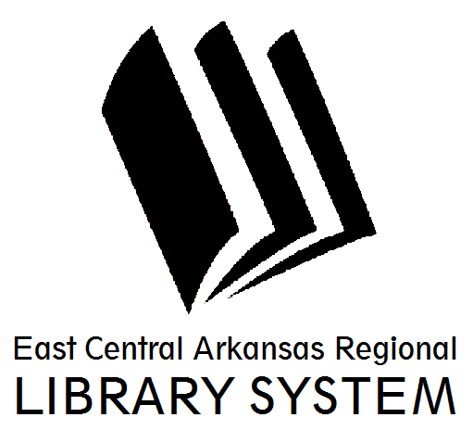
East Central Arkansas Regional Library System
410 E. Merriman Avenue, Wynne AR 72396
PRESS RELEASE

Date: 6/13/2016
For more information, contact Claire Miller, Deputy Director 870-587-0580
_____________________________________________________________________________________
Author Visit at Cross County Library
Cross County Library will be hosting an Author Visit with Mr. Willie Fields, currently of the Wynne area on Monday, June 27th @ 12pm during Brown Bag Book Talk.
According to his author bio, Mr. Fields has written approximately twenty books, he has worked as a Social Worker, Drug Counselor, Project Administrator, and Case Manager. He is a graduate of Mississippi Industrial College and holds a B.A. degree in Sociology. He has attended Spalding University Graduate School of Psychology in Louisville, Kentucky as well as City University of New York School of Sociology where he studied Field Ethnology. He also attended Sierra School of Business in Los Angeles, California.
Mr. Fields’ has written several screenplays, several collections of poetry and four theatrical plays. He has lived in 15 states in the U.S. His poetry has been read in Coffee Houses in Los Angeles, and Louisville, Kentucky.
He has been an EXTRA in the movie “CONGO” and “CROSSING GUARD”. He is no doubt one of the most prolific writers of this age.
For more information about story times and programs please visit us at www.ecarls.org or at facebook.com/crosscountylibrary. You may contact us at (870) 238- 3850. Our friendly staff is always looking forward to assisting you.

Claire Miller
Deputy Director
Cross County Library
cmiller@crosscountylibrary.org
870-587-0580

