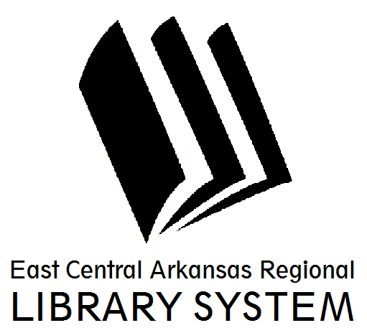
East Central Arkansas Regional Library System
410 E. Merriman Avenue, Wynne AR 72396
PRESS RELEASE

Date: 03/01/2017
For more information, contact Asti Ogletree, Youth Services Coordinator at 870-238-3850
_____________________________________________________________________________________
The East Central Arkansas Regional Library will now offer “1000 Books before Kindergarten” a free program for families with toddlers. This program encourages families to read 1,000 books with your child before he or she starts kindergarten.
The concept is simple, read a book (any book) to your child. The goal is to have read 1,000 books (yes you can repeat books) before your little one starts kindergarten.
We encourage parents to make it exciting at each milestone by giving your child a small reward. Then upon completion, visit your local library (bring in your reading sheet) and your child will be presented with a certificate of completion, a completer reward and, get their picture taken with their favorite librarian!
This program is self-paced and can take anywhere from a few months to a few years depending on when you begin the program. All children in the household who have yet to start kindergarten are eligible to participate.

For more information you may contact Mrs. Tree at the Cross County Library at (870) 238- 3850. Our friendly staff is always looking forward to assisting you.

Asti Ogletree
Youth Services Coordinator
Cross County Library
aogletree@crosscountylibrary.org
(870) 238-3850

