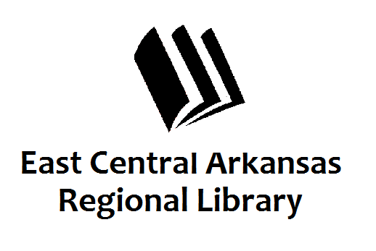
PRESS RELEASE
April 13, 2017
For additional information, contact:
Karen Golden, Operations Manager,
Woodruff County Libraries at 870-347-5331.

Money Smart Week

Informational programs at the Augusta Library

AUGUSTA, April 13th –
April 22nd-29th is Money Smart Week. During this week community groups, financial institutions, government agencies, educational organizations, and financial experts work together to educate consumers to better manage their personal finances.
This year the library has two programs planned for Money Smart Week. On Monday, April 24th, children are encouraged to come by and play Monopoly. This game helps teach children how money saved or spent determines their financial standing. The program will begin at 5:30 pm for those interested.
On Wednesday, April 26th, Kristina Carnes, Community Educator with the Arkansas Attorney General’s office will be here at 10:00 am to present a program on Identity Theft and Scams. This presentation will help consumers become aware of some of the scams going around and how to prevent becoming a victim. It will also give tips on what you can do to protect your identity as well as what steps to take if your identity has been stolen.
As always, the library wishes to help the community to become better informed and provide the resources to make this possible.
The Augusta Library is located at 201 Mulberry Street. For more information, please contact Karen or Melinda at 870-347-5331.

