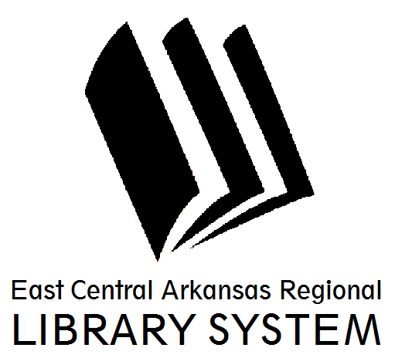
East Central Arkansas Regional Library System
410 E. Merriman Avenue, Wynne AR 72396
PRESS RELEASE

Date: 10/17/2016
For more information, contact Claire Miller, Deputy Director 870-587-0580
_____________________________________________________________________________________
Testing and Education Reference Center @ Your Library
Are you trying to study to take the GED, a Nursing Exam, or the ASVAB? Did you know that you can access all of the study guides through your library website? Testing and Education Reference Center has separate tabs for High School, Career, College Prep, Graduate School and even International topics. You can prepare for CLEP, ACT, GED, GRE and many more tests. You can even take practice exams to see where you are and what you need to brush up on before the actual exams. This is just another resource available free to people with our library card. You can access TERC under the Resources Tab on www.ecarls.org.
For more information on library resources, programming, and more, please visits us online at www.ecarls.org. Don’t forget to like your branch on facebook to keep up with the latest news.

Claire Miller
Deputy Director
Cross County Library
cmiller@crosscountylibrary.org

